**ASSIGNMENT 03**

INHERITANCE

Single inheritance:

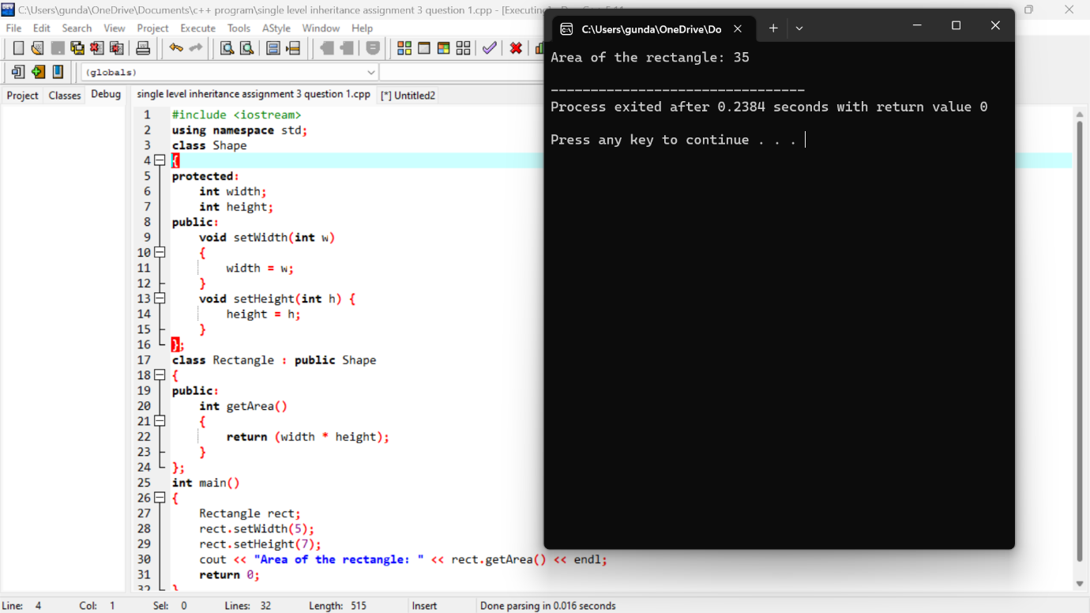

Multilevel inheritance:

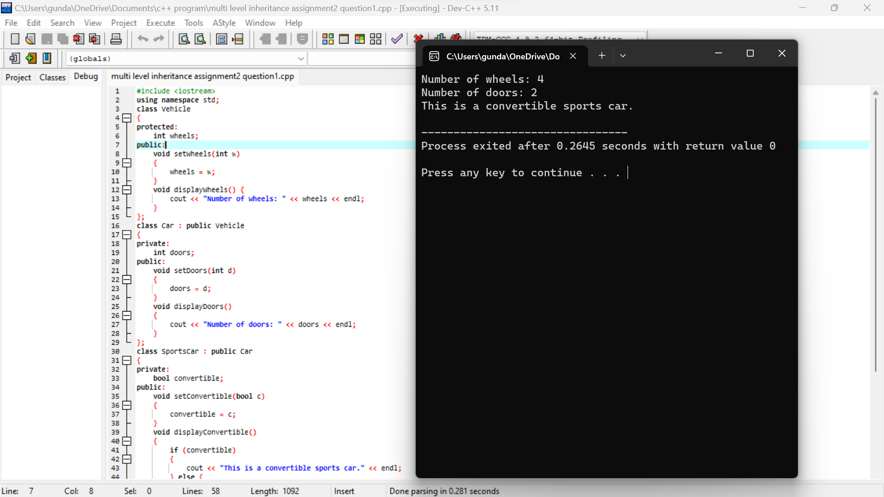

Multiple level inheritance:

